

**DANTE AV**

**CST01-Group6**

| **成员姓名** | **学号** | **贡献度** | **负责内容** |
| --- | --- | --- | --- |
| 况小媛颖 | 202219102 | 23% | Project Description + Sensitivity Analysis |
| 王月姮 | 202219044 | 21% | Cash-flow + Monte Carlo |
| 李佳怡 | 202219077 | 21% | Cash-flow + Executive Summary |
| 齐军 | 202219015 | 20% | Financial Evaluation + Qualitative Risk Analysis |
| 戴方华 | 202219072 | 15% | Recommendation and Suggestions |

* **AUDINATE**

Contents

Executive Summary 3

1 Project Description 4

2 Project Cash-Flow Statement 5

3 Financial Evaluation 8

4 Project Risk Assessment 10

4.1 Qualitative Risk Analysis 10

4.2 Quantitative Risk Analysis 12

• SENSITIVITY ANALYSIS 12

• MONTE CARLO METHOD 13

5 Recommendations and suggestions for further analysis 16

Bibliography 18

Appendices 19

# Executive Summary

This report is a financial assessment of the Dante AV project which was developed by Audinate. It provides various AV applications from enterprises to large venues. This report collects the financial information of the project in detail and proposes Alternative A (Enhanced Technology Adoption) and Alternative B (Business As Usual).

Based on reasonable assumptions, we make the cash flow statement; Then evalute the project. The cash flow shows that the NPV of both alternatives is greater than 0, indicating that it is worth investing. Among them, Alternative A has a higher life cycle cost and higher investment risk, but has a higher return value in the future; while Alternative B provides a conservative growth path, but has lower financial risk.

Then a quantitative and qualitative risk analysis is conducted. Alternative A has greater uncertainty in implementation, while Alternative B has the risk of relying on the existing customer base. Finally, based on the above analysis, The report makes further analysis and recommendations to guide decision makers on whether to develop the project.

# **1 Project Description**

Dante AV, developed by Audinate Group Limited, is a transformative initiative in the field of digital audio and video (AV) networking. The project, launched in 2019 with a planned 15-year development cycle, aims to revolutionize AV transmission by integrating advanced hardware and software technologies. Using Ethernet-based transmission, Dante AV eliminates the complexity of traditional analog cabling, enabling high-quality, low-latency synchronization of audio and video signals.

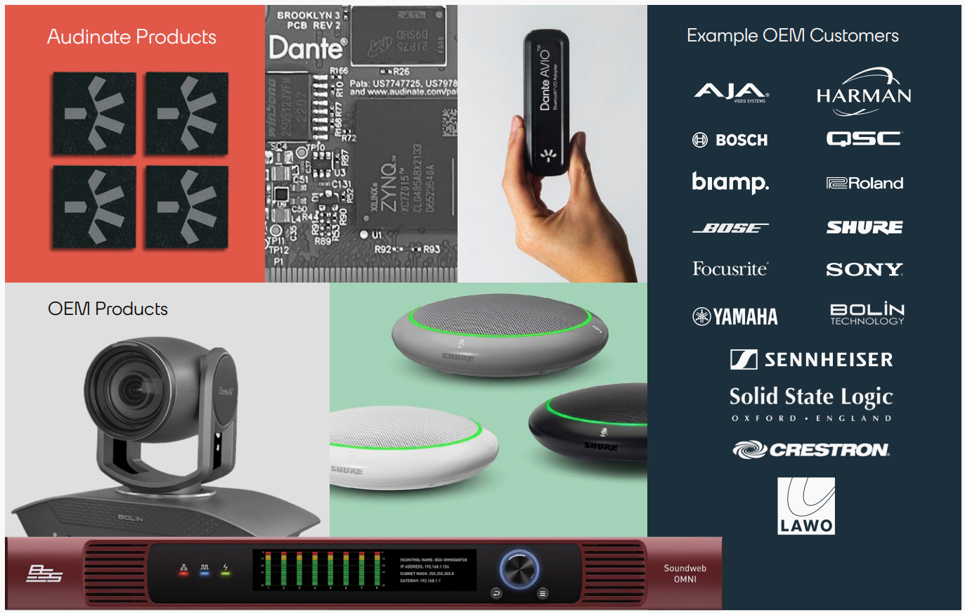 Central to its technical design is a modular hardware architecture that supports scalable deployment, seamles ssystem integration, and cost-effective maintenance. With its focus on high-performance processors and enhanced connectivity, Dante AV caters to a broad range of applications, including corporate offices, educational campuses, and large-scale venues like stadiums, positioning itself as a versatile and forward-looking

***Picture1 Dante AV Solution***

solution in the competitive AV market.(Smith, 2020).

The decision environment for Dante AV reflects both opportunities and challenges. As global demand for integrated and reliable AV systems grows, Audinate faced the strategic choice between accelerating innovation or focusing on incremental improvements. **A** Enhanced Technology Adoption：The accelerated approach emphasizes hardware advancements such as real-time voice separation and optimized video processing, targeting high-growth sectors like education and enterprise. **B** Business as Usual： Alternatively, a gradual development strategy would enhance system compatibility and reliability, ensuring steady market growth while retaining existing customers. These strategies were shaped by the evolving industry landscape and the increasing need for scalable, high-performance AV solutions.

Audinate’s robust financial position prior to project implementation ensured the feasibility of this ambitious undertaking. With total assets of $189.47 million and a low debt ratio of 10.02%, the company demonstrated strong financial health. A current ratio of 8.88 highlighted its excellent liquidity, while a return on equity of 6% reflected effective capital utilization. These indicators underscored Audinate’s capacity to invest in cutting-edge technology and position Dante AV as a market leader, driving innovation and addressing the growing demands of the AV industry.

# **2 Project Cash-Flow Statement**

**For Alternative A:**

Audinate's Dante AV project has been operational since 2019, and specific cash flows for the 2019-2024 period can be found in the annual report. Mainly includes: Cost, Benefits, Salavage, Discount rate and the Project life.

For **cash-outflow**, Based on the annual report during the operation of the project, we predict that for the 2025-2034 period, the general capital cost of the project, including property and plant, will remain unchanged, but the cost of investment activities may increase slightly to a total of about $18,400,290. Option A is expected to develop and use new technologies: real-time voice separation technology with video enhancements, at an estimated development cost of $7,528,109.

Due to the development and use of new technologies, a certain amount of publicity and promotion is required, and more employees are required to operate, and the staff expenses and marketing expenses in the operating costs will increase.

The maintanace of new technologies requires timely updating and adjustment, and the maintenance cost is about 60% of the technology development cost.

The company is based in Australia, where income tax accounts for about 27% of revenue under local corporate tax policies.

Due to the development of new technologies, the company needs more funds for operation and maintenance, and needs more borrowings, and the financial cost and net foreign exchange cost will rise.

For **cash-inflow**, It is expected that after the new technology is put into use, it will open the distance education and large conference market, expand to high-demand industries, and attract more customers who need a clear voice. It is expected to bring in at least 4,000 regular VIP customers, with more than 10,000 users, which will significantly increase revenue, and the use of new technology can also improve application efficiency and customer retention, and broadly enhance brand value.

The equipment introduced with new technology is high-tech equipment, depreciation adopts the Straight-Line Depreciation method, which allocates the cost of assets over their useful life and considers the impact of an **inflation rate** of 2.96% (the inflation rate is calculated based on the average value of the past ten years);the life cycle of which is affected by market demand and the speed of scientific and technological development, and the salvage value is expected to increase in the case of wide application.

Considering that the project technology is relatively mature and the market demand is relatively certain, the Discount rate is expected to be low.

In addition, as a startup, the company does not want to have too much burden on borrowing, so the initial borrowed funds are 31,028,000, and the repayment period is 15 years. The annual repayment amount is calculated based on this.

The project requires a certain amount of development, testing, promotion and publicity time, and the project cycle is expected to be 15 years.

**For Alternative B:**

Audinate's Dante AV project follows a conservative technology development approach under Alternative B. The project was launched in 2019 with a planned life of 15 years, focusing on maintaining the status quo while gradually expanding the market.

The cash flow forecast for Alternative B is mainly based on financial assumptions based on the company's historical financial reports and Australian market conditions. Compared with the aggressive innovation of Alternative A, the forecast for Alternative B is more cautious.

For **cash-inflow**, we made assumptions on the project's increased revenue ($500,000) and cost savings ($4750,000) in 2024 based on financial reports. The revenue forecast uses existing company financial data for 2022 and 2023 as the basis. Based on the initial revenue of $46.3 million in 2022 and $​69.7 million in 2023, the growth rate is expected to be around 30% in the first 0th-7th years, and shift to a more conservative 3% growth in the following years. Compared to the more innovative alternative A, this approach has a relatively modest revenue stream; additional benefits are expected to be 10% of revenue in the first 0-7 years, decreasing to 3% thereafter. At the same time, based on the financial reports for 2023 and 2024, intangible benefits are expected to grow at 10% in the initial 0-7 years and 5% in the following years.

For **cash-outflow**, we made assumptions about the capital cost ($16,805,000) and operating cost ($54,900,000) of the project in 2024 based on the financial reports. For manufacturing and O&M cost, in the first 0th-7th years, considering that the initial investment of the project should be relatively large, it is calculated at 50% of revenue, and reduced to 25% of revenue in the 8th-15th year; operating costs are expected to remain at around 60% of revenue based on the company's financial situation; depreciation adopts the Straight-Line Depreciation method, which allocates the cost of assets over their useful life and considers the impact of an **inflation rate** of 2.96% (the inflation rate is calculated based on the average value of the past ten years);

Alternative B's capital investment is more conservative, with an investment of $12.76 million in 2023 and $10.4 million in 2024. Investment in the remaining years will follow a moderate growth of 7%; the residual value estimate is assumed to be 10% of capital investment; the calculation of financial costs assumes 4% of depreciation; investment in working capital accounts for about 7% of revenue.

In addition, as a startup, the company does not want to have too much burden on borrowing, so the initial borrowed funds are $5,000,000, and the repayment period is 15 years. The annual repayment amount is calculated based on this.

The specific cash flow table and other partial explanations will be presented in the appendix.

# **3 Financial Evaluation**

Two alternatives are being considered for this project: Alternative A aims to accelerate Dante AV's development through increased research and development to expand the market, while Alternative B focuses on enhancing existing features for steady growth. The feasibility of these alternatives will be evaluated using financial viability indicators such as Payback Period (PB), Net Present Value (NPV), and Benefit-Cost Ratio (BCR), Life Cycle Cost(LCC)，based on the company’s latest annual report

**Assumptions:** The depreciation rate is set at 9.5%, the impact of inflation is taken into account, the project duration is 15 years, and it is assumed that market demand will maintain steady growth.

**PB--**Payback Period：PB refers to the length of time required to recover the initial cash outlay for the project.(Ruegg & Marshall, 1990) The Static PB approach is used, which ignores the time value of money. For Alternative A, the project will take 7 years to break even starting from 2019, while Alternative B will require 8 years to achieve the same result, under the same conditions.

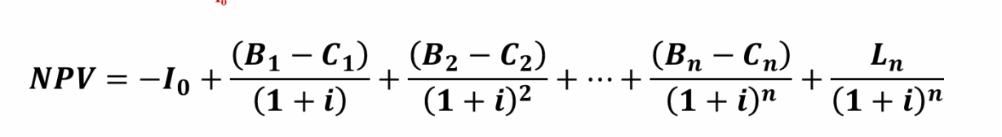

Io = Initial Investment *i* = Discount rate

B = annual benefits n = Estimate project’s life

C = annual operating cost L=End-of-life salvage value of the assets

**NPVA = $113,309,581.24 NPVB =$45,352,587.37**

**NPV**--NPV calculates the difference between the present value of cash inflows and the present value of cash outflows related to an investment project(Gallo, 2014). The calculation is performed according to the formula above. Since the NPV values for both Alternative A and B are greater than 0, it indicates that the benefits of the projects exceed the costs, making them worthwhile investments.

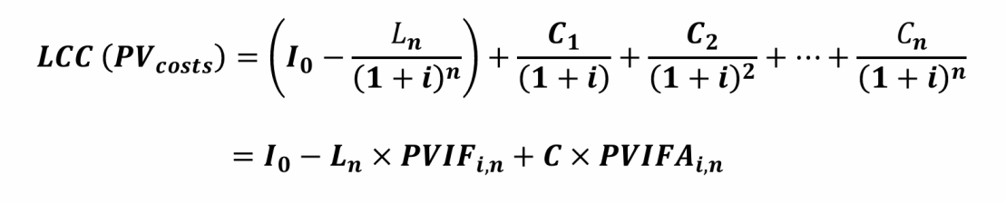

**LCCA = $1,007,606,784.75 LCCB = $778,577,651.18**

**LCC--(Life Cycle Cost** )It is the total cost of owning, operating, maintaining, and disposing of a project or product over its entire life. (Larsen et al., 2022)It helps assess the long-term financial impact and make informed decisions, particularly when selecting between alternatives that provide similar services but have different cost structures .

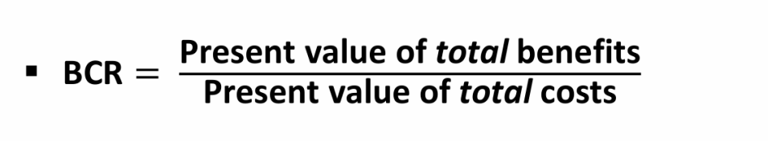

**BCR--(**Benefit-Cost Ratio) BCR measures project profitability by dividing total benefits by total costs, with BCR > 1 indicating economic viability. It is calculated using Net Present Benefit (NPB) and Net Present Cost (NPC), where NPC uses the Life Cycle Cost (LCC) as a proxy for total costs.After calculation ,BCR**A** =1.16 ,BCR**B** =1.07.

**PBA<PBB NPVA>NPVB LCCA>LCCB BCRA>BCRB**

**Summary**

Analyzing PB, NPV, BCR, and LCC shows that while the payback period (PB) and benefit-cost ratio (BCR) of both options are similar, with BCR values close to 1, indicating almost equal costs and returns, alternative A has a higher net present value (NPV). This means its future cash flows provide a greater return on investment. Although alternative A has a higher lifecycle cost (LCC), its long-term returns are more attractive. Therefore, alternative A offers superior overall financial benefits and long-term investment returns, making it more suitable for decisions focused on long-term profit and sustainable growth.

# **4 Project Risk Assessment**

## 4.1 Qualitative Risk Analysis

### **•Alternative A and B common risks**

**1.Economic Fluctuations**

* **Probability**: Low
* **Impact**: High
* **Explanation**: Economic fluctuations can lead to significant changes in customer demand and market conditions, which directly affect the product's market performance. Economic uncertainty can result in revenue volatility and complicate investment decisions.
* **Relationship to Quantitative Variables**: Discount Rate

**2.Supply Chain Risk**

* **Probability**: Medium
* **Impact**: Medium
* **Explanation**: Supply chain issues such as delays in raw materials, production hold-ups, or logistics disruptions may affect timely delivery and project progress. Supply chain fluctuations can lead to rising costs or delays.
* **Relationship to Quantitative Variables**:Operating Costs and Net Income.

**3.Compliance and Regulatory Risk**

* **Probability**: Low
* **Impact**: High
* **Explanation**: As digital AV technology becomes more widespread, the regulatory environment is becoming stricter. Failure to meet new regulations or standards may lead to fines, business interruptions, or reputational damage.
* **Relationship to Quantitative Variables**:Operating Costs and Net Income.

### **•Alternative A -Unique Risks**

**1.High R&D Investment Risk**

* **Probability:** Medi
* **Impact:** High
* **Explanation:** Enhancing technology adoption requires a substantial R&D investment, which could lead to budget overruns or extended development timelines. If the R&D does not successfully deliver the new technology as planned, it could result in wasted funds and affect the company’s cash flow.
* **Relationship to Quantitative Variables:**Capital Investment and Net Income.

**2.Technology Implementation Challenges**

* **Probability:** Medium
* **Impact:** High
* **Explanation:** Even with technological innovations, there might be challenges in implementing the technology. For example, performance issues, compatibility problems, or integration challenges with hardware/software could arise. These challenges may lead to higher development and implementation costs, delays, or reduced market appeal.
* **Relationship to Quantitative Variables**:Operating Costs and Net Income.

### **•Alternative B-Unique Risks**

**1.Over-reliance on Existing Customer Base**

* **Probability:** Medium
* **Impact:** Medium
* **Explanation:** Over-relying on the existing customer base might neglect the development of new markets and new customers. This exposes the company to the risk of revenue decline if existing customers leave or the market becomes saturated.
* **Relationship to Quantitative Variables:**Net Income and Additional Benefits.

**2 Technological Obsolescence**

* **Probability:** Medium
* **Impact:** High
* **Explanation:** Continuing to use existing technology without significant innovation can lead to technological obsolescence. The emergence of new technologies in the market could render the existing technology obsolete, affecting market share and leading to sales decline.
* **Relationship to Quantitative Variables:**Net Income and Capital Investment.

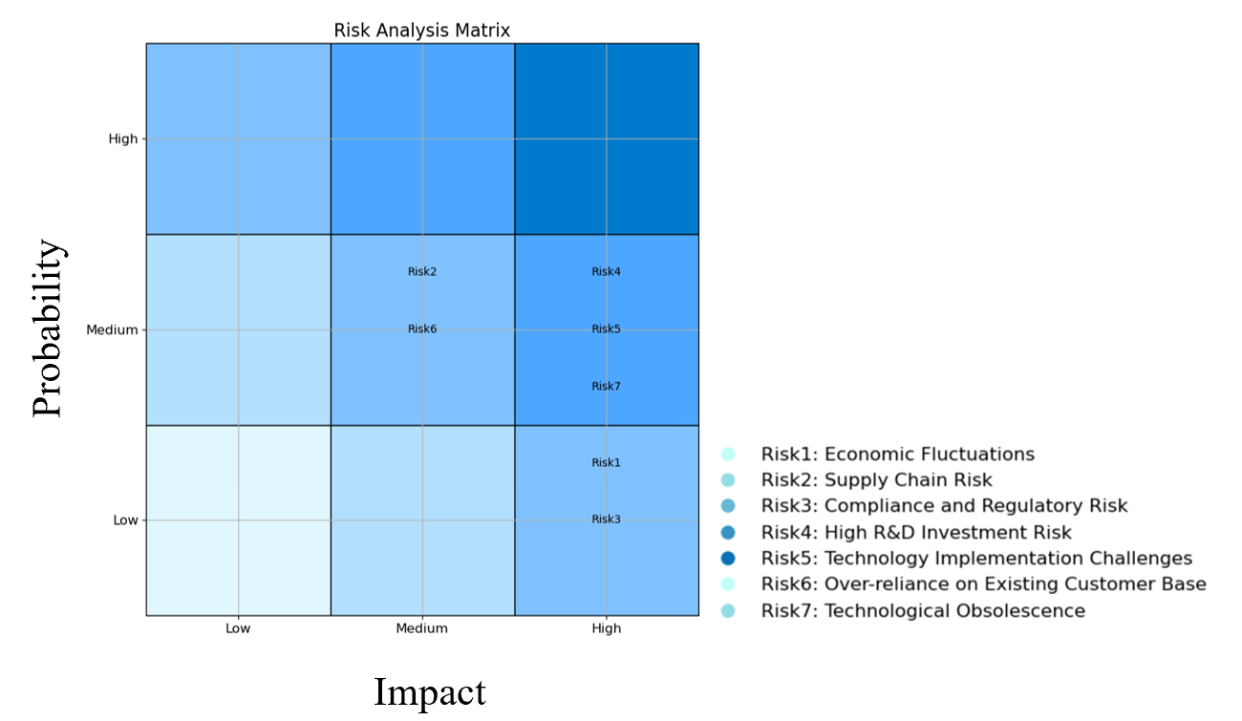

***Picture2 probability and impact matrix***

## 4.2 Quantitative Risk Analysis

### • SENSITIVITY ANALYSIS

To effectively assess the financial performance of the project under uncertain conditions, we conducted a sensitivity analysis on two scenarios to identify the impact of each key variable on NPV and compared them through ranking.

We selected the same10 key variables from both scenarios, and by varying the percentage deviation of their inputs, we calculated the corresponding NPV values, as shown in the *table 1*. Based on this, the sensitivity of each variable was ranked, resulting in a visual representation, as shown in the *figure 3*.

***Table 1 Sensitivity Analysis Table***

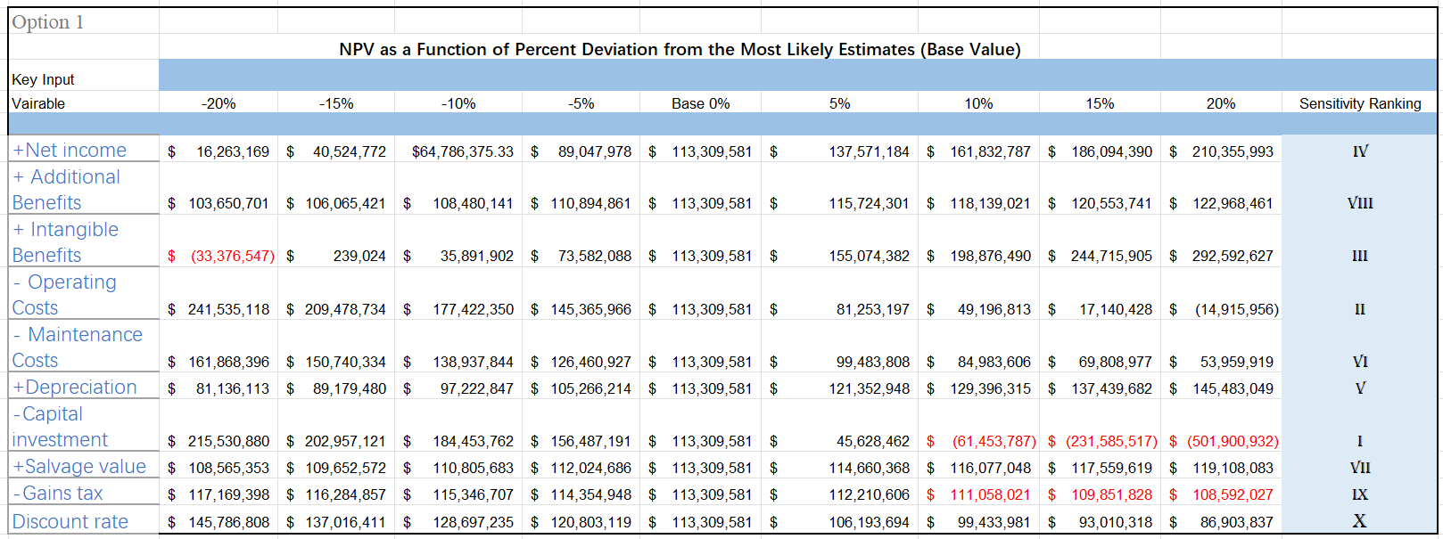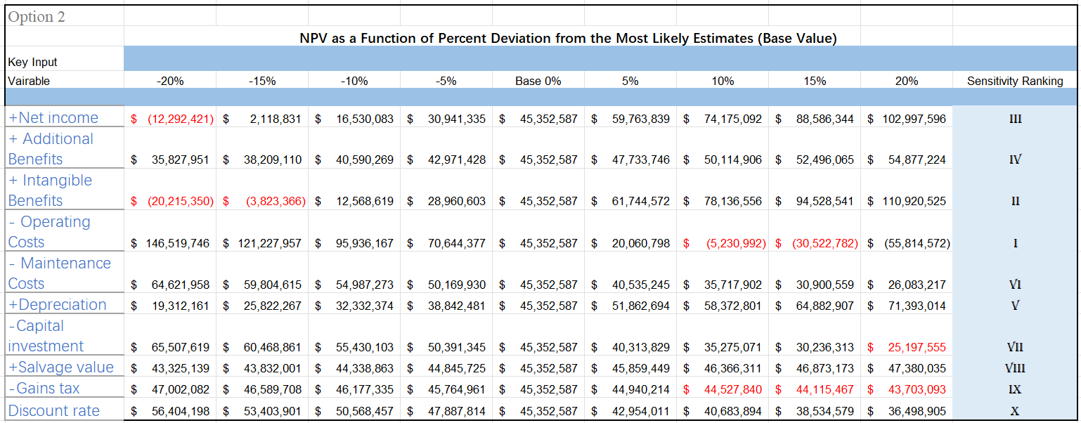

In Alternative A, the sensitivity analysis results indicated that capital investment had the greatest impact on NPV, followed by operating costs and intangible benefits. In Alternative B, operating costs were identified as the most influential variable on NPV, followed by intangible benefits and net income.

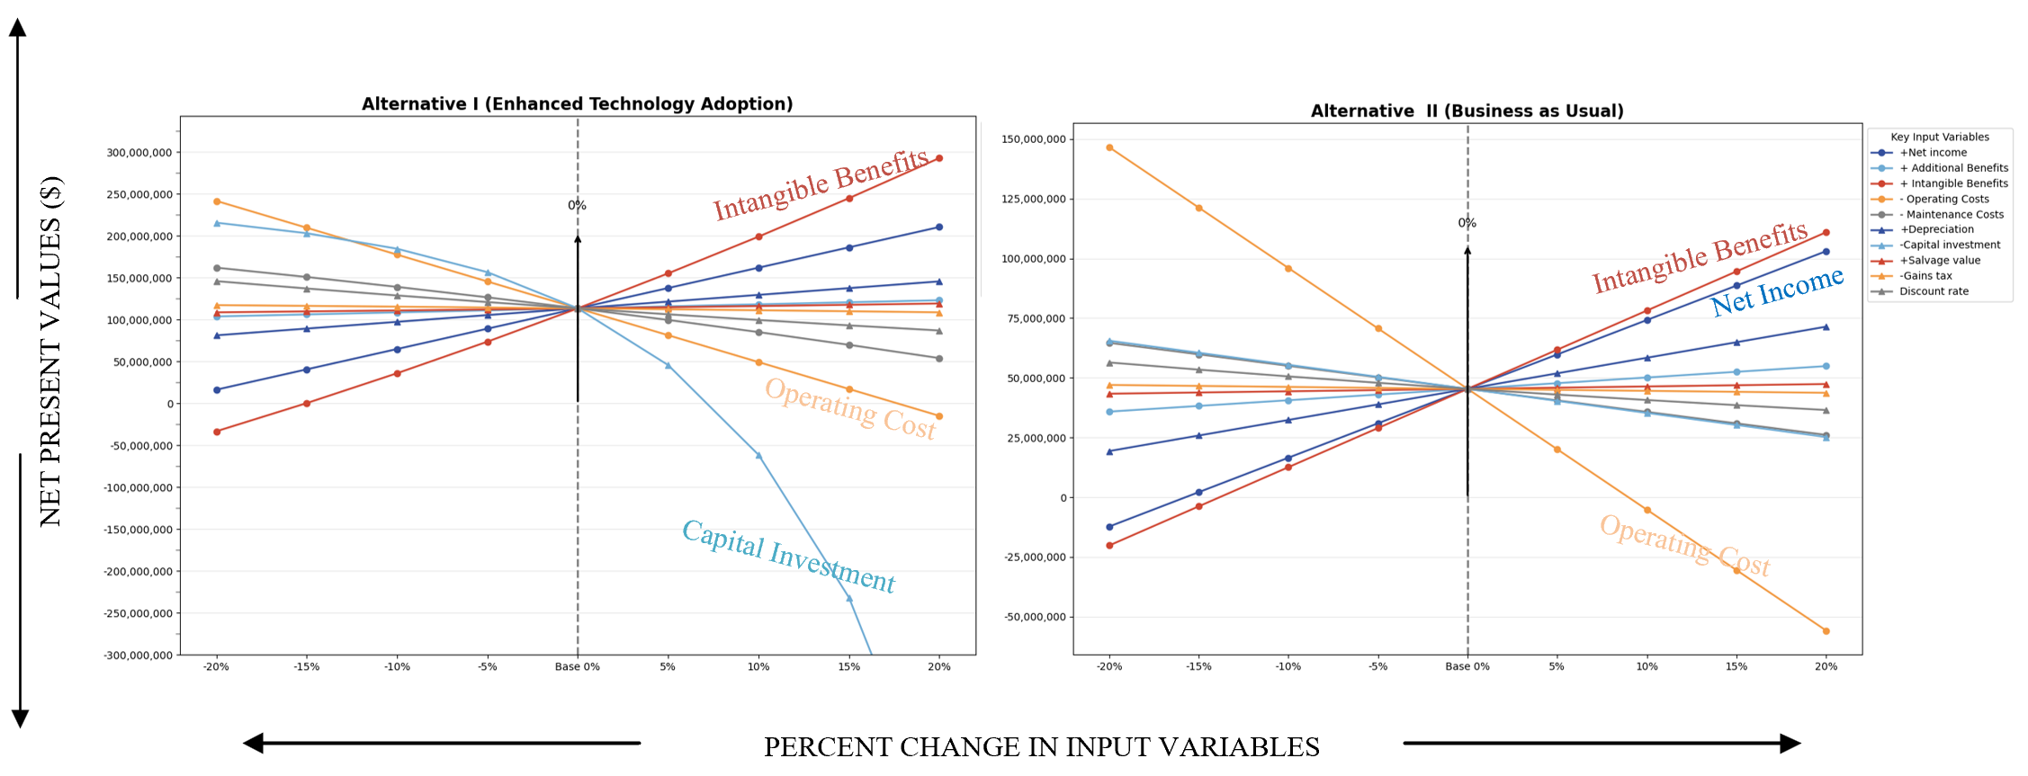

***Picture 3 Sensitivity Analysis Graphs for 2 Alternatives***

In conclusion, Alternative A performs well in terms of net income and depreciation, making it suitable for projects that seek long-term returns. However, it may pose higher risks when there are significant fluctuations in capital investment and operating costs. Alternative B, on the other hand, is more robust in risk control, particularly demonstrating strong NPV stability when capital investment and operating costs are stable. It is better suited for projects that prioritize financial stability. Therefore, if the project can tolerate greater fluctuations and aims for higher returns, A is more appropriate; if the focus is on risk control and stability, B is the better choice.

### • MONTE CARLO METHOD

To determine which variables have a significant effect on financial performance, we use the Monte Carlo simulation method.

The impact on the net present value (NPV) of the project is assessed by analyzing changes in the values of individual key factors. According to the characteristics of plan A and Plan B, we selected 9 key variables as research objects.

Assuming that cost and revenue follow normal distribution, the mean and standard deviation of each parameter are determined respectively, and the corresponding NPV value is calculated based on this.

Monte Carlo simulations generate multiple random scenarios (10,000 simulations), each corresponding to a different set of input values (i.e., random values for each key factor). Finally, the simulation results show how often different NPV values occur when a single key variable changes.

The mean value, maximum value, minimum value and standard deviation of NPV for Alternative A and Alternative B are shown in ***Table 2*** in an intuitive graphical form, as shown in ***Picture 4***.

***Table 2 Monte Carlo simulation Table***

|  |  |
| --- | --- |
| Alternative A |  |
|  |  |
| Expected Net Present Value | 124937838.89 |
| Max | 429614004.52 |
| Min | -2238747.15 |
| Standard Deviation | 44445864.41 |

|  |  |
| --- | --- |
| Alternative B |  |
|  |  |
| Expected Net Present Value | 50754600.31 |
| Max | 163307042.96 |
| Min | -16973452.51 |
| Standard Deviation | 21683083.05 |

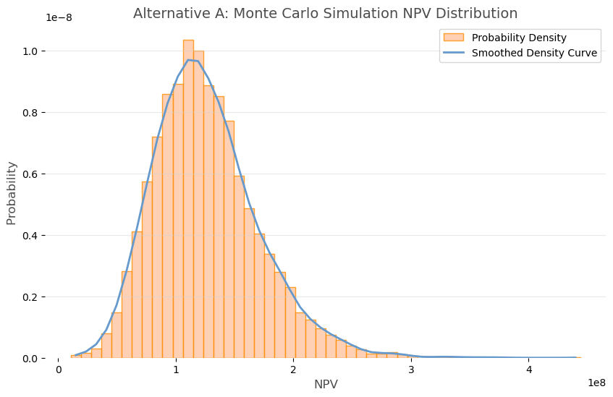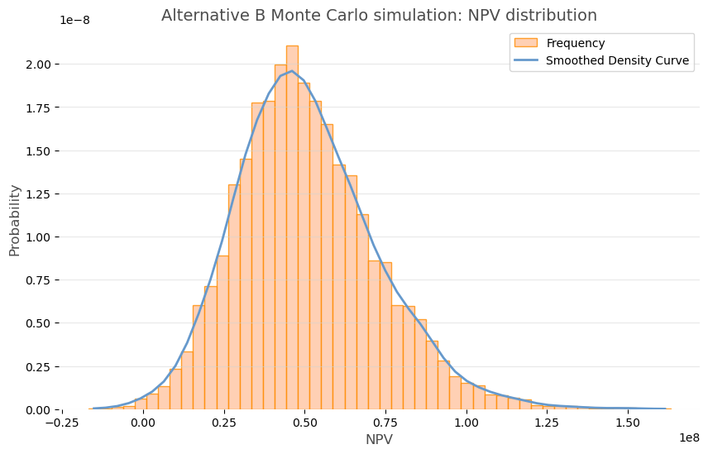

***Picture 4 Monte Carlo simulation diagrams for 2 Alternatives***

# **5 Recommendations and suggestions for further analysis**

It can be seen that although Dante AV research and development project has certain risks, the probability of occurrence of these risks is not high, and its significant technical advantages and wide application prospects are expected to bring high profit returns and competitive advantages to the company. Therefore, it is recommended that decision-makers actively support the Alternative A. And take effective measures to improve the company's financial status and risk management level. Although there are certain R&D and market risks associated with the project, the company can mitigate these risks through effective risk management and market strategies.

In the process of research and development, the company can set phased goals to gradually verify the feasibility of the technology and market demand. At the same time, through market research and competitive analysis, the company can more accurately grasp the market trends and customer needs, so as to develop more targeted market strategies. Once the technology matures and is successfully brought to market, the company will be able to quickly capture market share and achieve profit growth with its technological advantages and market leadership. In addition, with the continuous upgrading of technology and the continuous expansion of the market, the company can also maintain a competitive advantage through continuous innovation and optimization of products to achieve long-term stable development.

In order to enhance the company's financial status, the following suggestions can be used for reference:

1. Accurate budget and fund management: Before starting a research and development project, a detailed budget preparation and fund management plan should be carried out to ensure the rational use and effective control of project funds.
2. Diversified financing channels: Considering that R&D projects require a large amount of capital investment, the company should actively seek diversified financing channels, such as bank loans, venture capital, etc., in order to spread financial risks and ensure the smooth progress of the project.
3. Strengthen marketing and branding: During the research and development process, the Company should strengthen marketing and branding efforts to increase the visibility and influence of Dante AV.
4. Establish a risk early warning and response mechanism: The company shall establish a sound risk early warning and response mechanism for the risks and challenges that the project may face. Through regular risk assessment and monitoring, potential problems are discovered and solved in time to ensure the stable development.

While the report provides a detailed analysis of the risks and benefits of the Dante AV project, it does not point to factors such as possible policy impacts or market movements. This may lead to unforeseen obstacles in the implementation of the project, such as rising costs, shrinking market demand, etc., which will affect the overall project revenue and the realization of the company's strategic objectives. In order to improve the predictability and guidance of the report, more factors should be comprehensively considered, the prediction and analysis of future trends should be strengthened, and targeted risk response strategies and plans should be proposed.

# **Bibliography**

1. Audinate Annual Report 2024.https://www.audinate.com/company/history.2024
2. Smith, J. (2020). "The Growth of Ethernet-Based AV Solutions: A Case Study of Dante AV." Journal of Audio-Visual Technologies, 15(3), 45-58.
3. Ruegg, R. T., & Marshall, H. E. (1990). Payback (PB). In Springer eBooks (pp. 92–104). https://doi.org/10.1007/978-1-4757-4688-4_7
4. Gallo, A. (2014). A refresher on net present value. Harvard Business Review, 19, 1-6.
5. Larsen, V. G., Tollin, N., Sattrup, P. A., Birkved, M., & Holmboe, T. (2022). What are the challenges in assessing circular economy for the built environment? A literature review on integrating LCA, LCC and S-LCA in life cycle sustainability assessment, LCSA. Journal of Building Engineering, 50, 104203. <https://doi.org/10.1016/j.jobe.2022.104203>
6. Australian Bureau of Statistics[物价指数和通货膨胀 |澳大利亚统计局 --- Price indexes and inflation | Australian Bureau of Statistics](https://www.abs.gov.au/statistics/economy/price-indexes-and-inflation)

# **Appendices**

Appendices A Tables

**1 Project info**

|  |  |
| --- | --- |
| **Project Description** | **Dante AV** by Audinate is a pioneering, industry-leading integrated engineering project for digital audio and video (AV) networking, encompassing the entire lifecycle of technology development, hardware production, market promotion, and service implementation. This project enables high-quality, low-latency transmission of audio and video over Ethernet networks, revolutionizing traditional analog cabling and marking a significant technological breakthrough in the field of AV transmission. The core strengths of Dante AV lie in its software-based centralized management and modular design, which make system setup, expansion, and optimization highly efficient and flexible, while significantly reducing overall deployment and maintenance costs. It is designed to meet diverse demands, from small conference rooms to large stadiums.  Launched in 2019 with a planned development cycle of 15 years, this engineering project aims to build a fully integrated ecosystem of hardware and software. It not only drives the digital transformation of the AV industry but also delivers sustainable and efficient solutions for users worldwide. |
| **Alternative A** | **Enhanced Technology Adoption**  This alternative includes accelerating Dante AV's technological expansion, particularly in terms of voice separation and enhanced video capabilities. By advancing new features such as real-time voice separation technology and low-latency video transmission optimization, audiate can position itself as a leader in high-quality video networks. This approach targets fast-growing, high-demand markets such as large educational campuses and corporate offices, emphasizing Dante AV's advanced video integration capabilities. Increased R&D and strategic marketing efforts will prioritize driving adoption, capturing new opportunities and expanding the impact of Dante AV. |
| **Alternative B** | **Business as Usual**  Under this alternative, Audinate would continue with the current development strategy for Dante AV, focusing on gradual updates and incremental improvements. This approach aims to enhance Dante AV’s existing audio and video functionalities, such as compatibility, reliability, and user experience, to retain and grow its established customer base. By building on its reputation without significant new investments, Audinate would target steady growth, leveraging Dante AV’s market acceptance to increase adoption and expand into additional sectors. |

**2 Financial status of the Company**

|  |  |
| --- | --- |
| **Indicators** | **Values** |
| **Total assets** | $189,474,000 |
| **Debt Ratio** | 10.02% |
| **Current Ratio** | 8.88 |
| **Total Assets Turnover** | 0.48 |
| **Return on Equity** | 6.00% |
| **Price-to-Earnings Ratio** | 0.72 |

**3 Assumptions**

**For Alternative A**

|  |  |  |
| --- | --- | --- |
| **Assumption - Alternative A** | | **Values** |
| **Cost** | Capital Cost | $25,928,399 |
| New technology development cost | $7,528,109 |
| Operating cost | $70,455,000 |
| Maintanace cost | $11,973,000 |
| Additional maintenance costs | $4,789,200 |
| Tax cost | $9,882,000 |
| Finance cost | $698,378 |
| Net foreign exchange cost | $1,082,432 |
| **Benefits** | Increased Revenue | $36,600,000 |
| Cost Savings | -$26,075,062 |
| Improved Efficiency | $59,652,547 |
| Customer Retention | $1,200,000 |
| Brand Value Increase | $3,000,000 |
| Market Expansion | $6,500,000 |
| **Salvage value** | | $1,352,000 |
| **Discount rate** | | 0.095 |
| **Project life** | | 15 years |

**For Alternative B**

|  |  |  |
| --- | --- | --- |
| **Assumption - Alternative B** | | **Values** |
| **Cost** | Capital Cost | $16,805,000 |
| Operating cost | $54,900,000 |
| Maintanace cost | $11,973,000 |
| Tax cost | $10,870,200 |
| Finance cost | $366,000 |
| Net foreign exchange cost | $145,000 |
| **Benefits** | Increased Revenue | $500,000 |
| Cost Savings | $4,750,000 |
| Improved Efficiency | $300,000 |
| Customer Retention | $1,000,000 |
| Brand Value Increase | $18,830,000 |
| Market Expansion | $14,575,000 |
| **Salvage value** | | $500,000 |
| **Discount rate** | | 0.095 |
| **Project life** | | 15 years |

**4 CBA**

**For Alternative A**

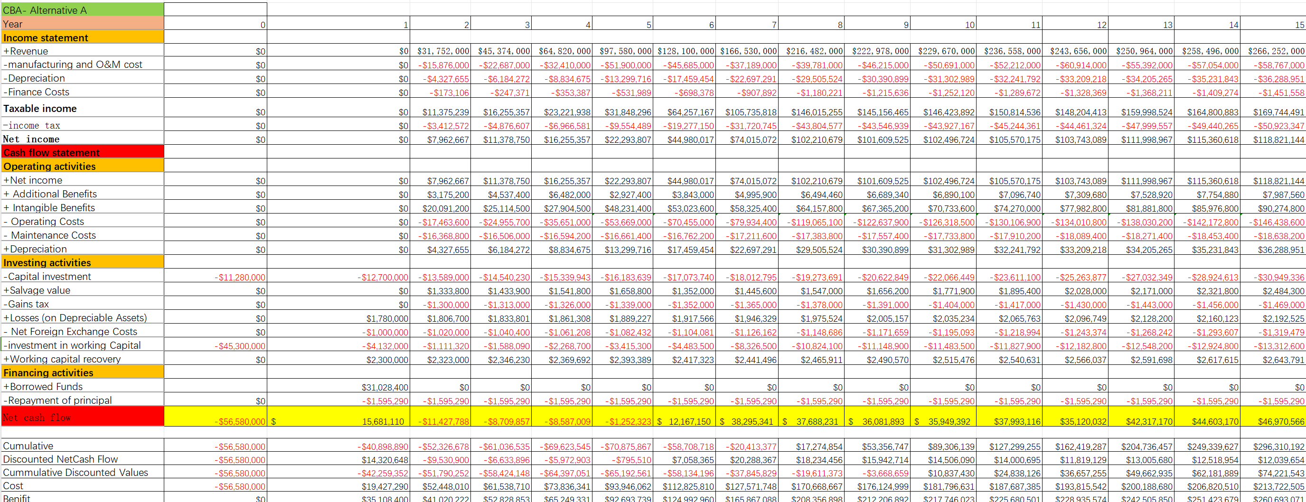

**For Alternative B**

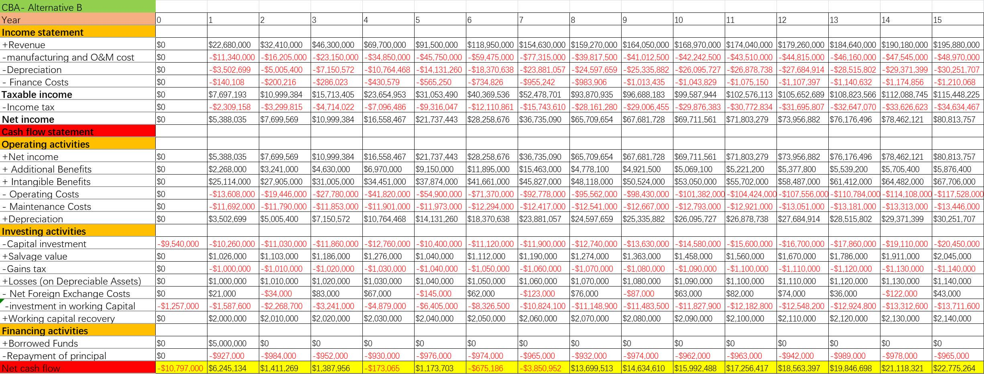

Appendices B Graphs

**1 Sensitivity Analysis**

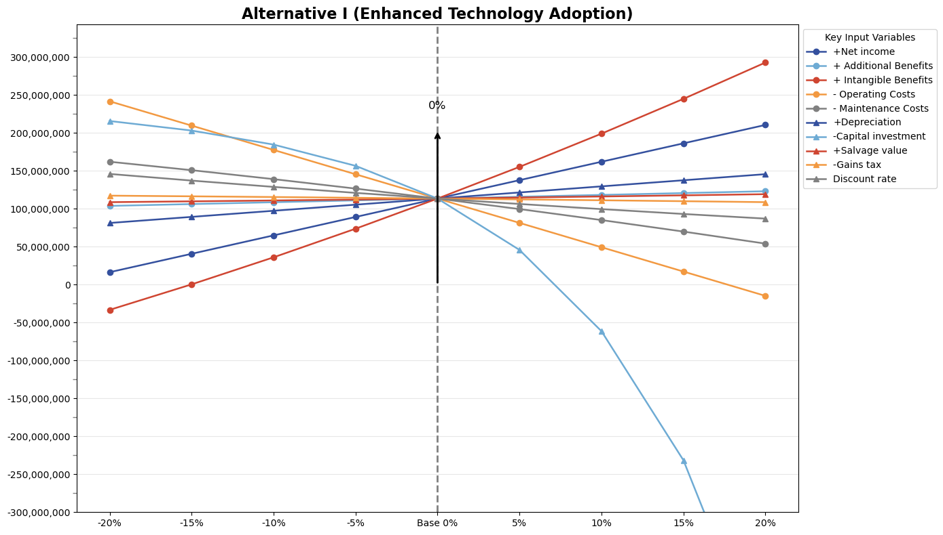

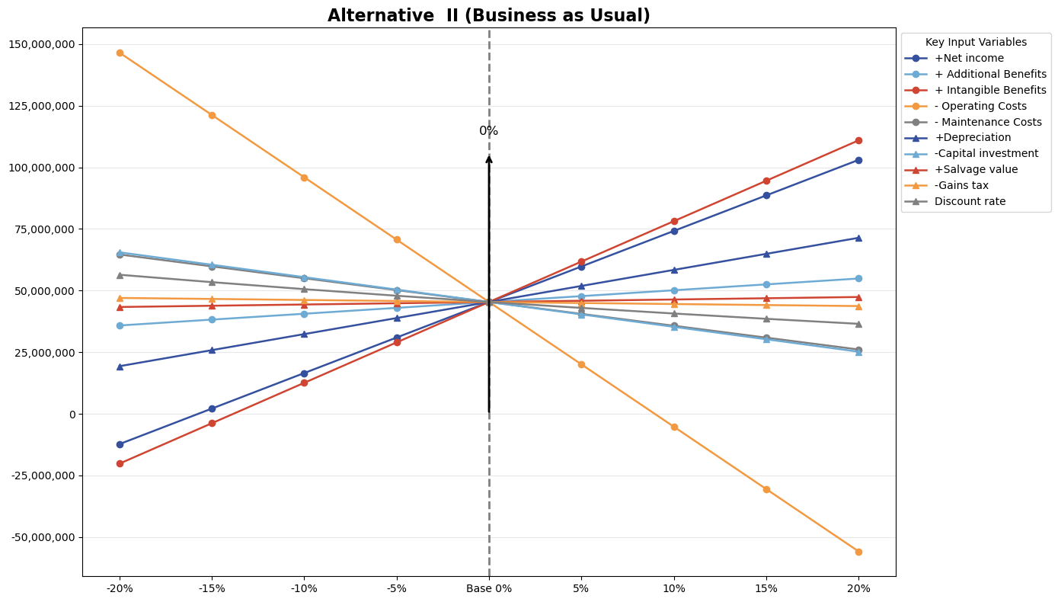

Appendices C Assupmtions

**1 Cash Flow Statement Assumptions**

**For Alternative A**

**Income tax**

According to the income tax forecast stipulated by Australia, the income tax of this project is 30% of revenue

**Additional Benefits**

With the use of new technologies, the program will be more widely used in education, large conferences, and about 10% of revenue

**Intangible Benefits**

The development of new technologies will enable the project to occupy a favorable segment in the distance education and large conference related market, which will maintain a steady growth of 14% per year

**Maintenance cost**

According to the financial report, the maintenance cost in 2024 is expected to be $16,661,400, maintaining a stable growth of 1.4% each year

**Salvage cost**

Salvage cost is about 13% of income

**Gains tax**

According to the company's financial situation, gains tax is expected to remain roughly unchanged, maintaining a growth of 1% each year

**Net foreign exchange costs**

According to the financial report and the international economic environment, it is predicted that it will be between tens of thousands and hundreds of thousands each year

**Working capital recovery**

According to the financial report, it is predicted that it will be around 2 million each year, maintaining a growth of 1%

**For Alternative B**

**Income tax**

According to the income tax forecast stipulated by Australia, the income tax of this project is 30% of revenue

**Maintenance cost**

According to the financial report, the maintenance cost in 2024 is expected to be $12,173,000, maintaining a stable growth of 1% each year

**Salvage cost**

Salvage cost is about 10% of income

**Gains tax**

According to the company's financial situation, gains tax is expected to remain roughly unchanged, maintaining a growth of 1% each year

**Net foreign exchange costs**

According to the financial report and the international economic environment, it is predicted that it will be between tens of thousands and hundreds of thousands each year

**Working capital recovery**

According to the financial report, it is predicted that it will be around 2 million each year, maintaining a growth of 1%